Order Of Service

Singing: Psalm 2—CW page 65

Reading: Psalm 125

Opening Hymn: TLH 574

Reading: Romans 10:10-15

Request Hymn: CW Supplement 769

Reading: Matthew 21:12-17

Sermon Hymn: TLH 63

Sermon Text: Luke 3:1-6

In The Wilderness

Prayer

The Apostles’ Creed, TLH page 12

Holy Communion

The Lord's Prayer

The Blessing

Closing Hymn: TLH 566

* * * * * * * * * * *

Koinonia Hour

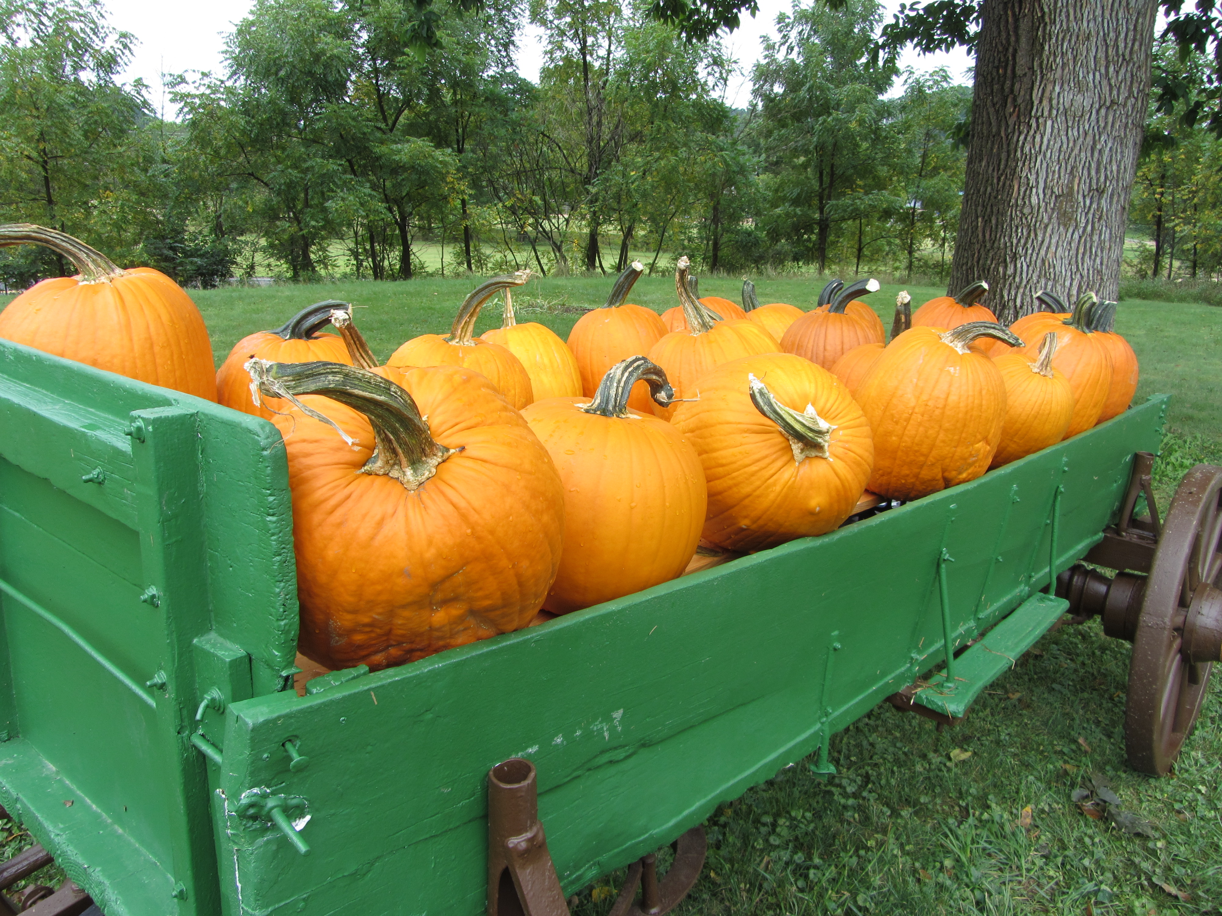

Seedtime And Harvest

Water
Of
Life

6 December 2020

W A T E R O F L I F E

Independent Christian Church—Conservative Lutheran Doctrine

Worship Service: 9:30 a.m. Bible Study: 10:45 a.m.

Larry Cooper, Pastor E-Mail address:
111 N. Ridge Road lcooper@wateroflife.cc
Coon Valley, WI 54623 Web Site:
www.wateroflife.cc

* * * * * * * * * * * * * * * * * * * * * * * * * * *

Sermon Text: Luke 3:1-6

In The Wilderness

* * * * * * * * * * * * * * * * * * * * * * * * * * *

Luke 3:1 Now in the fifteenth year of the reign of Tiberius Caesar, Pontius Pilate being governor of Judaea, and Herod being tetrarch of Galilee, and his brother Philip tetrarch of Ituraea and of the region of Trachonitis, and Lysanias the tetrarch of Abilene,
:2 Annas and Caiaphas being the high priests, the word of God came unto John the son of Zacharias in the wilderness.
:3 And he came into all the country about Jordan, preaching the baptism of repentance for the remission of sins;
:4 As it is written in the book of the words of Esaias the prophet, saying, The voice of one crying in the wilderness, Prepare ye the way of the Lord, make his paths straight.:
5 Every valley shall be filled, and every mountain and hill shall be brought low; and the crooked shall be made straight, and the rough ways shall be made smooth;
:6 And all flesh shall see the salvation of God.

